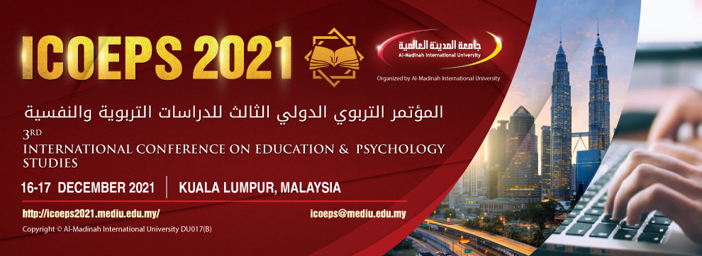
Participation form
Personal details
Full Name:
Nationality:
Official/Academic Title:
Occupation:
Affiliation:
Address:
Hand phone:
Email Address:
 | From outside Malaysia  ( ) with attend ( ) without attend | From Malaysia  ( ) with attend ( ) without attend
 | ( ) From outside Malaysia (without paper) | ( ) From Malaysia (without paper)
 | ( ) Student
 | Please tick (✔) beside suitable choice.
Research Title:
Research Field:
Notice: please send this form together with a copy of your recent resume and your personal photo to this email address: (icoeps@mediu.edu.my).

